Lab 11 - Display and Placing Elements

Instructions
- Answer the below question in the boxes if needed.
- For coding exercises, code on your computer and zip all your code before submission.
- Please submit the assignment after you finish.
- NO INLINE CSS CAN BE USED FOR THIS LAB

Part 1: Inline HTML
Steps:

- Go to VS Code and open the folder that we created in Lab 1
- Create a new HTML file inside the folder name "display.html". You can use the HTML skeleton we included in Chapter 1.
- Build HTML elements inside the body to replicate the screenshot below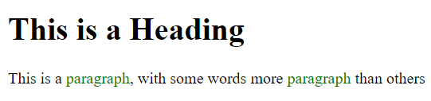
- Make the green paragraph words block elements
- Hide the green paragraph words and ensure the spaces occupied by them are filled up (No blank spaces). (Hint: Shall we use display: none or visibility: hidden?)

Part 2: Float

- Continuing on the HTML file in Part 1. Add three images below the text from Part 1. Use float property to arrange the three images like the screenshot below. (You don’t need to use the exact same image. You can find any 3 images from the internet)

- Take a screenshot and name it as “Part2.png” or “Part2.jpg”.

Part 3: Displaying Elements
- Continuing on Part 2, use display: none or visibility: hidden styling to recreate the screenshot below. Note that the first image is hidden but still occupying the space. The second image is hidden but its space is occupied by the third image.

- Zip the html file with the screenshot in Part 2 and submit.

